 LIST OF CONTENTS:

**1. INTRODUCTION**

**1.1 Project Overview**

**1.2 Purpose**

**2. LITERATURE SURVEY**

**2.1 Existing problem**

**2.2 References**

**2.3 Problem Statement Definition**

**3. IDEATION & PROPOSED SOLUTION**

**3.1 Empathy Map Canvas**

**3.2 Ideation & Brainstorming**

**3.3 Proposed Solution**

**3.4 Problem Solution fit**

**4. REQUIREMENT ANALYSIS**

**4.1 Functional requirement**

**4.2 Non-Functional requirements**

**5. PROJECT DESIGN**

**5.1 Data Flow Diagrams**

**5.2 Solution & Technical Architecture**

**5.3 User Stories**

**6. PROJECT PLANNING & SCHEDULING**

**6.1 Sprint Planning & Estimation**

**6.2 Sprint Delivery Schedule**

**6.3 Reports from JIRA**

**7. CODING & SOLUTIONING (Explain the features added in the project along with code)**

**7.1 Feature 1**

**7.2 Feature 2**

**7.3 Database Schema (if Applicable)**

**8. TESTING**

**8.1 Test Cases**

**8.2 User Acceptance Testing**

**9. RESULTS**

**9.1 Performance Metrics**

**10. ADVANTAGES & DISADVANTAGES**

**11. CONCLUSION**

**12. FUTURE SCOPE**

**13. APPENDIX**

**1. INTRODUCTION:**

             Prediction of crude oil prices has been a wide topic for ages. People use their intuition and lot of techniques to guess the prices of

crude oil. It takes a lot of knowledge about the crude oil to accurately predict it. Predicting the crude oil price is very significant in

various economic, political and industrial areas, both for crude oil importer and exporter countries. Since the crude oil is important

strategic resource around the globe; it has become the crucial commodity for the world’s economy. Thus, prediction of prices of

crude oil has always been considered as a very exciting and challenging task which drew the curiosity of professionals, researchers

and organizations all over the world.

Moreover, crude oil volatility has a critical impact on macroeconomic parameters such as such as inflation, unemployment,

exchange rate, economic growth of countries whose economy rely heavily on crude oil export or import. Thus, crude oil price

prediction can help governments of countries of the world in economic policymaking and make quick and operative economic

decisions to hedge against probable risk in these economic parameters. Therefore, forecasting of crude oil prices is quite useful and

is also the objective of this paper. In this, we have used LSTM based recurrent neural networks for the purpose of crude oil price

prediction.

**1.1 Project Overview**

           Crude oil quite a lot of plastics and other synthetic materials are derived from oil and higher prices ripple through the economy. With high oil prices, then, comes increased interest and R&D into non-oil alternative feedstocks for these materials.

**By the end of this project you will be able to:**

* Know fundamental concepts and techniques of time series forecasting and LSTM

* Gain a broad understanding of time series data.

* Know how to split the data for time series forecasting.

**1.2 Purpose**

      Crude oil price fluctuations have a far reaching impacton global economics and thus price forecasting can assist in minimising the risks associated with volatility in oil prices.price forecasting are very important to various stakeholder:governments, public and private enterprises, policymakers, and investors.

**2. LITERATURE SURVEY**

crude oil price forecasting has attracted tremendous attention from scholars and policymakers due to its significant effect on the global economy.

Besides supply and demand, crude oil prices are largely influenced by various factors, such as economic development, financial markets, conflicts, wars, and political events. Most previous research treats crude oil price forecasting as a time series or econometric variable prediction problem. Although recently there have been researches considering the effects of real-time news events, most of these works mainly use raw news headlines or topic models to extract text features without profoundly exploring the event information. In this study, a novel crude oil price forecasting framework, AGESL, is proposed to deal with this problem. In our approach, an open domain event extraction algorithm is utilized to extract underlying related events, and a text sentiment analysis algorithm is used to extract sentiment from massive news. Then a deep neural network integrating the news event features, sentimental features, and historical price features is built to predict future crude oil prices. Empirical experiments are performed on West Texas Intermediate (WTI) crude oil price data, and the results show that our approach obtains superior performance compared with several benchmark method.

**2.1 Existing problem**

           The price of oil fluctuates according to three main factors: current supply, future supply, and excepted global demand.Members of OPEC control 40% of the world'"s oil.

         Forecasting is notoriously difficult, and nobody guessed how high stock prices would be today.But the most interesting miss was that the group was way too low on oil prices

**2.2 References**

The proposed AGESL approach outperforms all other benchmarks. It achieves the highest DS, the lowest RMSE, and MAPE among all models. Compared with all the other benchmark models, it averagely achieves better accuracy in terms of lift 14.62% on RMSE, 17.00% on MAPE, and 12.50% on DS. Even Compared with the suboptimal LSTM Event, the RMSE, MAPE, and DS of AGESL obtain a lift of 1.62%, 2.72%, and 4.73%, respectively. It demonstrates that a hybrid framework integrating the advantages of its subcomponents is more capable of crude oil price forecasting.

**2.3 Problem Statement Definition**

*This paper proposed a hybrid model for crude oil price prediction that uses the complex [network analysis](https://www.sciencedirect.com/topics/engineering/electric-network-analysis) and long short-term memory (LSTM) of the deep learning algorithms.

      *The complex network analysis tool called the visibility graph is used to map the dataset on a network and K-core centrality was employed to extract the non-linearity features of crude oil and reconstruct the dataset.

       *The complex network analysis is carried out in order to preprocess the original data to extract the non-linearity features and to reconstruct the data. Thereafter, LSTM was employed to model the reconstructed data.

       * To verify the result, we compared the empirical results with other research in the literature. The experiments show that the proposed model has higher accuracy, and is more robust and reliable.

**3. IDEATION & PROPOSED SOLUTION**

**Data retrieval and pre-processing in data retrieval, datasets can be fetched such of news data, black gold price data and market data. Dataset from news can be retrieved through headlines as it is easier to obtain and justifies in one line. Factors that affect the prediction are expert business, stock market and later business. Sentimental Analysis In this era of modernization, big data is also assisting through study of sentiment analysis which focuses on retrieving data through news and proposing prediction model. In this kind of analysis dictionary-based approach is accounted to gather the data regarding markets and essential factors affecting it.**

**3.1 Empathy Map Canvas**

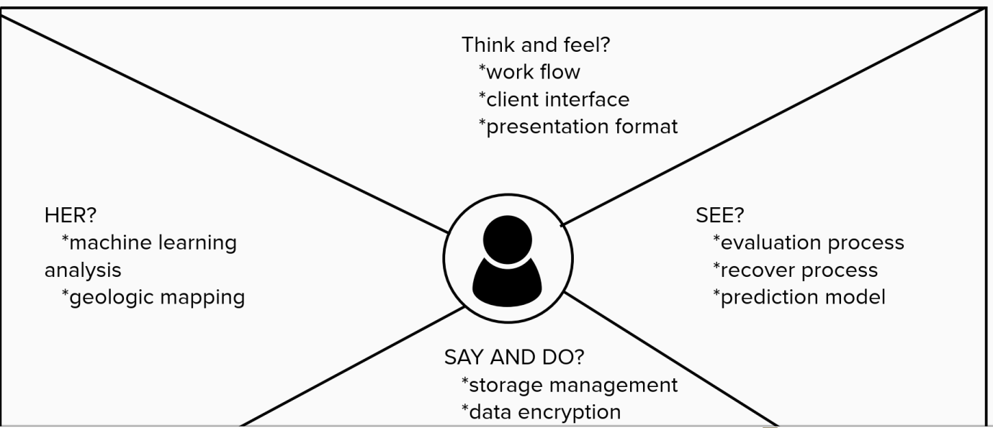

**3.2 Ideation & Brainstorming**



**3.3 Proposed Solution**

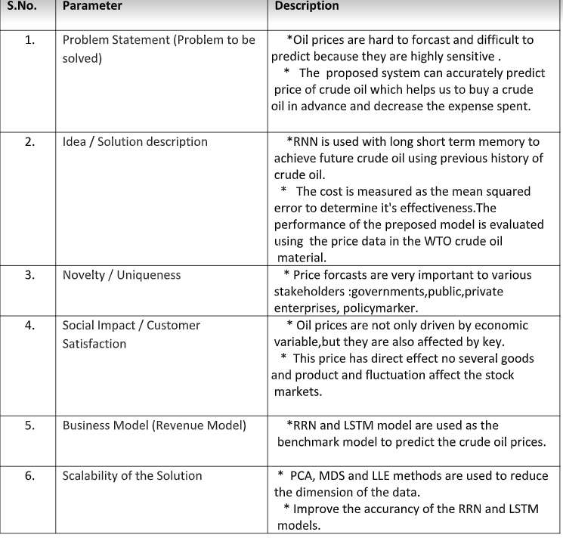

**3.4 Problem Solution fit**

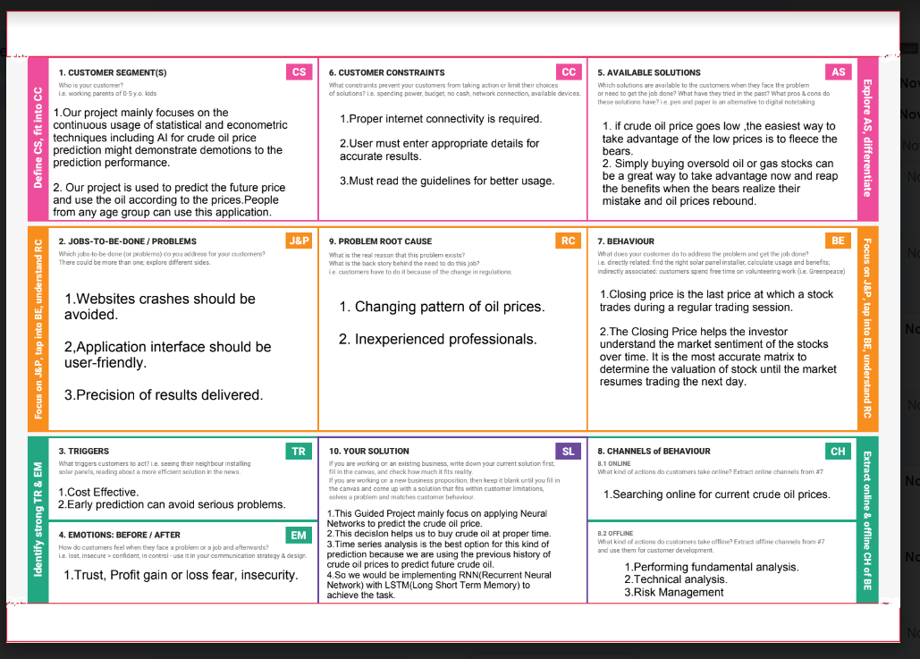

**4. REQUIREMENT ANALYSIS**

**Oil demand is inelastic; therefore the rise in price is good news for producers because they will see an increase in their revenue. Oil importers, however, will experience increased costs of purchasing oil. Because oil is the largest traded commodity, the effects are quite significant. A rising oil price can even shift economic/political power from oil importers to oil exporters. The crude oil price movements are subject to diverse influencing factors. Our work mainly focuses on applying Recurrent Neural Networks to predict the Crude Oil Price. This decision helps common people to buy crude oil at the proper time. Time series analysis is the best option for this kind of prediction because we are using the previous history of crude oil prices to predict future price of the crude oil. So we would be implementing RNN (Recurrent Neural Network) with LSTM (Long Short Term Memory) to achieve the task. We will be experimenting with different types of models with varying number of epochs, look backs and other tuning methods.**

**4.1 Functional requirement**

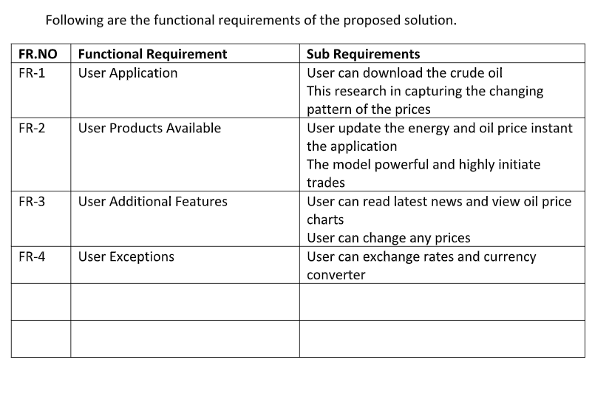 **4.2 Non-Functional requirements**

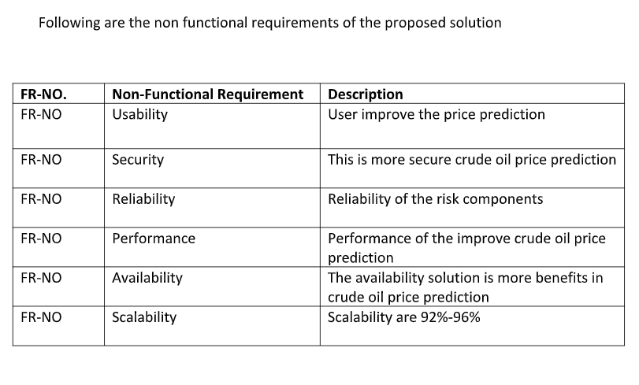

**5. PROJECT DESIGN**

System design the main aim of this structure incorporated in study can fetch out data from economic news and propose this sets into prognosticate model. Major phases in formulated system include data collection and pre-processing, feature and factor selection and price appraisal and prediction. In the initial hand, news, financial and market data are gathered and processed. In Further aspect, unstructured documents are modified into structured extract by CNN classification. Data retrieval and pre-processing in data retrieval, datasets can be fetched such of news data, black gold price data and market data. Dataset from news can be retrieved through headlines as it is easier to obtain and justifies in one line. Factors that affect the prediction are expert business, stock market and later business. Sentimental Analysis In this era of modernization, big data is also assisting through study of sentiment analysis which focuses on retrieving data through news and proposing prediction model.

**5.1 Data Flow Diagrams**

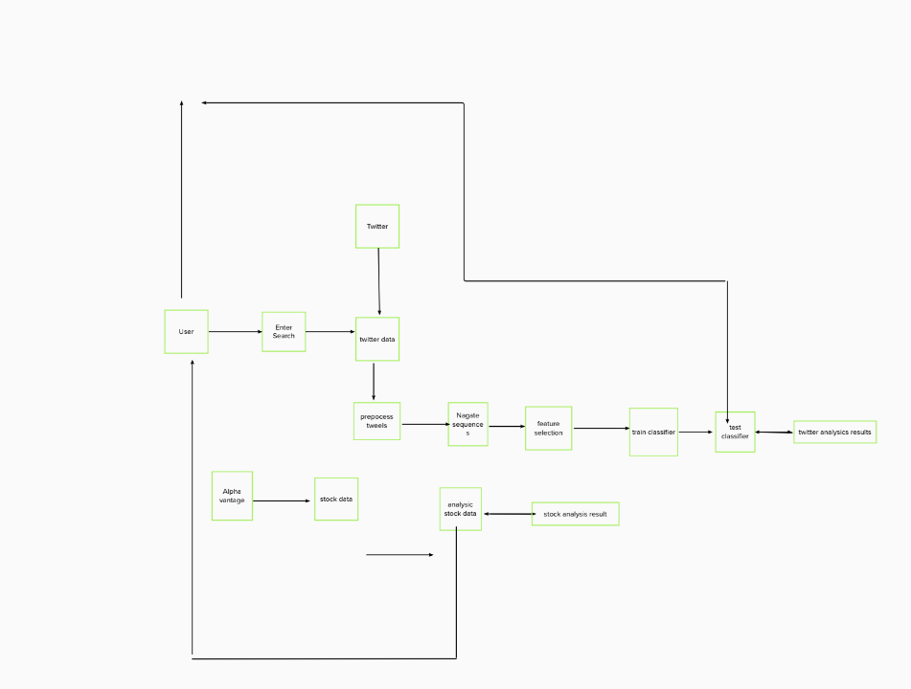

**5.2 Solution & Technical Architecture**

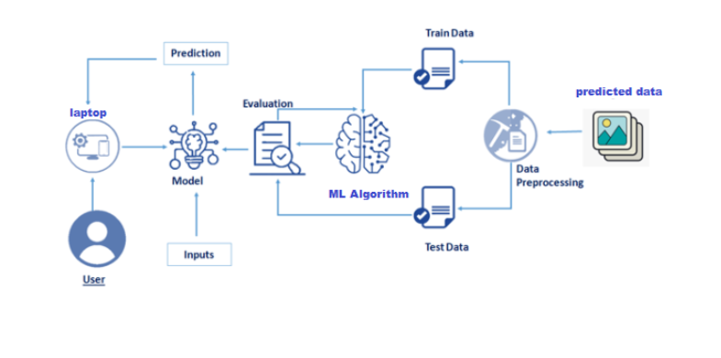

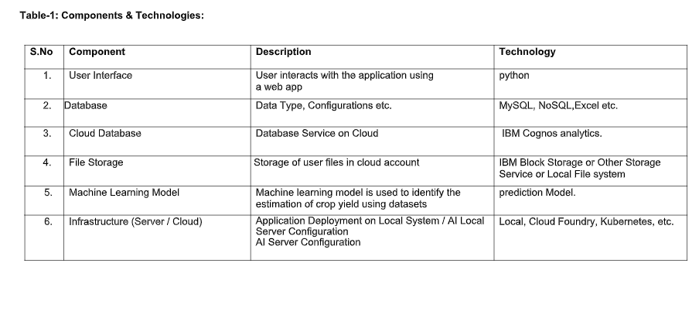

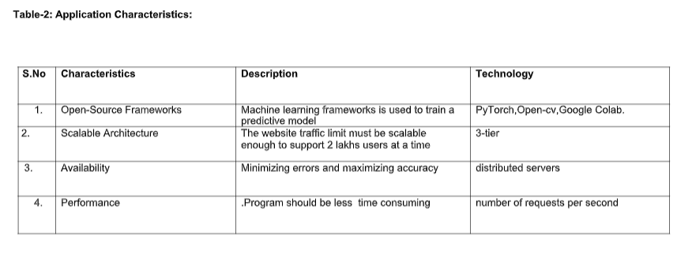**5.3 User Stories**

Conflicting supply-and-demand factors have increased uncertainty in oil price forecasts. Fears of a recession have intensified in both the US and Europe, which could hurt oil demand.  
  
 The actions of the world’s [central banks](https://capital.com/central-bank-definition), which have repeatedly hiked [interest rates](https://capital.com/interest-rates-definition) to fight surging inflation, along with an economic slowdown in China, have also bumped up the prospects of falling demand for the commodity.

In addition, extended sanctions against Russian oil exports have led to uncertainty about supply from the world’s second-largest producer.

**6. PROJECT PLANNING & SCHEDULING**

In this milestone you are expected to prepare milestones & tasks, sprint schedules.

**6.1 Sprint Planning & Estimation**

Use the below template to create product backlog and sprint schedule

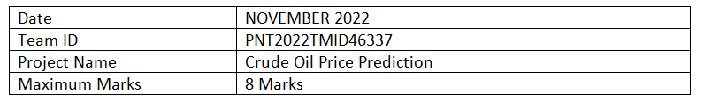

Use the below template to create product backlog and sprint schedule

|  |  |  |  |  |  |  |  |
| --- | --- | --- | --- | --- | --- | --- | --- |
| **Sprint** | **Functional Requirements** | **User Story Number** | **User Story/Task** | **Story Points** | **Priority** | **Team Members** |  |
| Sprint-1 | Registration | USN-1 | As a user, I can register for the application by entering my email, password, and confirming my password | 2 | High | INDHU ARASU |
| Sprint-1 |  | USN-2 | As a user, I will receive confirmation email once I have registered for the application | 2 | High | AASAI THAMBI BARANI |
| Sprint-1 |  | USN-3 | As a user, I can register application through Gmail | 3 | High | G.ABIRAMI |
| Sprint-1 |  | USN-4 | As a user, I can register application through Gmail | 2 | High | INDHU ARASU |
| Sprint-1 | Login | USN-1 | As a user, I can log into the application by entering email & password | 3 | High | SRIRANJANI RAJA |
| Sprint-1 |  | USN-2 | As a user, log into the application name & email | 3 | High | SRIRANJANI RAJA |
| Sprint-1 | Dashboard | USN-1 | The nature of crude oil , its price prediction becomes extremely difficult in crude oil price prediction | 5 | High | AASAITHAMBI BARANI |
| |  | | --- | |  |   Sprint-2 | Input Necessary Details | USN-1 | As a user, I can predict crude oil using machine learning model | 15 | High | SRIRANJANI RAJA |
| Sprint-2 | Data Pre-processing | USN-1 | Transform raw data into suitable format for prediction | 5 | High | AASAITHAMBI BARANI |
| Sprint-3 | Prediction of crude oil price | USN-1 | As a user, I can predict crude oil using machine learning model | 15 | High | G ABIRAMI |
| Sprint-3 |  | USN-2 | As a user, I can get accurate prediction of crude oil | 5 | High | SRIRANJANI RAJA |
| Sprint-4 | Review | USN-1 | As a user, I can give feedback of the application | 20 | High | INDHU ARASU |
| **6.2 Sprint Delivery Schedule** | | |  | |  |  |
|  | |

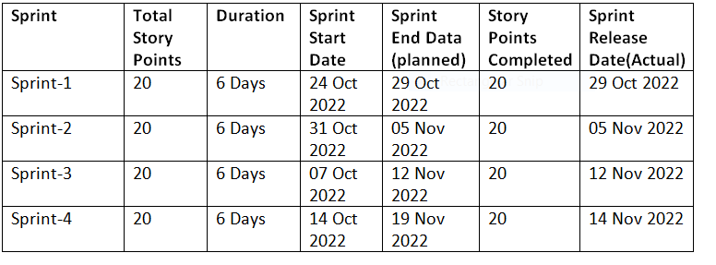**6.3 Reports from JIRA**

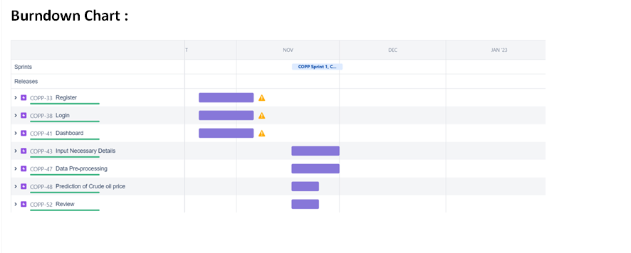

**10. ADVANTAGES & DISADVANTAGES**

Crude oil **generates heat**. Heating this material and other petroleum products can warm homes in colder weather, making modern living possible even in colder climates. This oil also produces energy. Many petroleum products are energy carriers

**The cost of shipping goods of all types rises**, since oil is used in nearly all methods of transports. The cost of materials that are made from oil, such as asphalt and chemical products, also rises. If the cost of oil rises, it tends to raise the cost of other fossil fuels.

**11. CONCLUSION**

**It has clears that an LSTM network is better than other traditional neural network for forecasting prices as it aims in using**

**back propagation model. Traditional neural network such as CNN on the other hand predicts the next outgoing but doesn’t**

**necessarily save the previous data or connection which is based on feed-forwarding, in the sense the previous data is not necessary**

**to predict the future data. LSTM focuses on storing the previous data and prediction which is rather encouraging and more**

**approximate. The outcome derived are relatively encouraging. The results show that large look ups do not necessarily improve the**

**accuracy of the predictions of crude oil prices. Hence it can be concluded, the model with single LSTM model is definitely the most**

**accurate.**

**12. FUTURE SCOPE**

**oil** futures are **contracts in which you agree to exchange an amount of oil at a set price on a set date**. They're traded on exchanges and reflect the demand for different types of oil. Oil futures are a common method of buying and selling oil, and they enable you to trade rising and falling prices.

**13. APPENDIX**

The availability of other energy sources. Oil price shocks can be quickly transferred into the macro-economy by different channels and then be passed on to consumers. Or rather, a set of macroeconomic indi cators, such as growth rate, employment, inflation rate and exchange rate, and investment decisions are undoubtedly quite sensitive to

crude oil still accounts for most of the globally produced energy and global dependence on oil is likely to continue in the days to come despite oil price shocks which are likely to occur. Given globally drastic increase in energy prices in recent times, the energy studies are likely to be critical for economic and policy. Of course, economic policies of the countries will have to respond to oil price shocks as soon as possible. That is the reason why oil prices should constantly be monitored by many economic agents. Therefore, the models that enable us to make accurate predictions for crude oil prices will always remain to be useful even after the epidemic is over. Considering all of these, our model will be undoubtedly beneficial for a wide range of economic agents from oil exporting and importing countries, households, investors, industrial production, traders in spot and futures markets to policymakers and central banks across the globe because complex features of crude oil prices affect their economic behaviors. In our opinion, the ability to stabilize some of the key macro and micro variables mentioned below should be accompanied by a model that captures the nonlinear properties of oil prices well because these variables tend to react to oil price shocks.